
Prof. Paul Liptz
19th Annual CSP One Month Scholar
January 5, 2020 – January 30, 2020

Fulfilling the Dream:
The Fascinating Story of Modern Israel

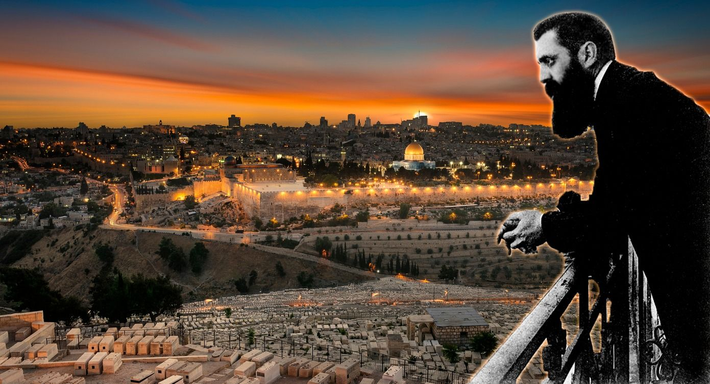
Dedicated in Honor of Roz and Elliot Vogelfanger

Supported by an Impact Grant from
Jewish Federation & Family Services Orange County
and a generous grant from the Jewish Community Foundation of Orange County
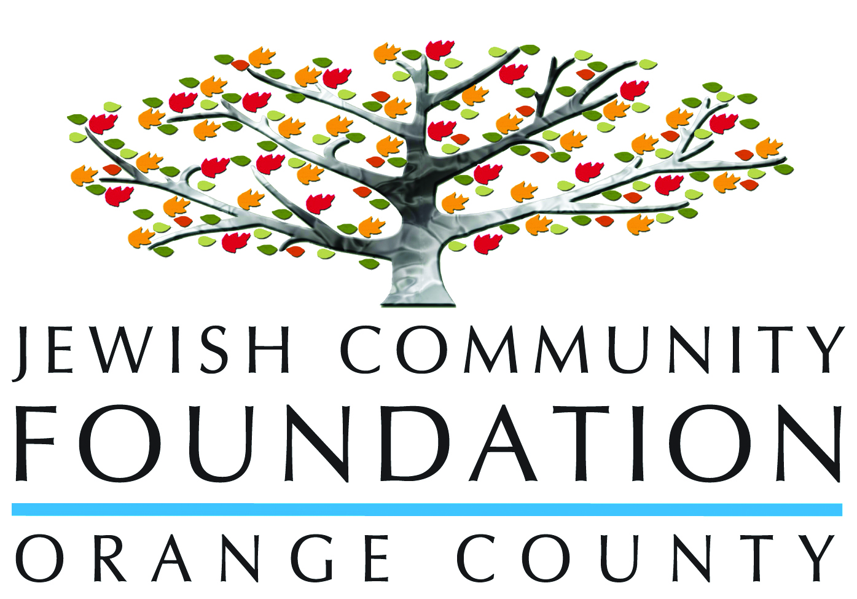

Israel is both an old and new land. For centuries, Jews have dreamed of building a safe homeland for themselves. After the Holocaust, a desperate people appreciated, once again, that only a State could ensure their survival but were aware that the challenges would be overwhelming. By 2020, successes are evident, but there is still a long road ahead of us.

Paul Liptz, a social historian, was on the Tel Aviv University faculty for 40 years, teaching graduate and undergraduate students in the Department of Middle East and African History and the International School, where he dealt with a wide range of topics. His main interests are History of the Yishuv [Pre-State], the Modern State of Israel and Arab Women and Nationalism in the Middle East. He taught graduate students at the Hebrew Union College in Jerusalem as well as at the Conservative movement seminary for 25 years, dealing with modern Jewish history, Israeli society and the contemporary Middle East. In the Israeli army reserves, he lectured officers and non-commissioned officers on non-military realms. He is still active in Israel and is involved in various academic and educational fields. In the last few decades, he has travelled the world extensively, lecturing and conducting workshops in some twenty countries. He has also been a visiting scholar with many American groups in Central and Eastern Europe. Paul was born in Rhodesia (Zimbabwe) and came as a volunteer to Israel one day before the Six Day War on June 4, 1967. He decided to stay in Israel, married Brenda and they have 4 children and 10 grandchildren.

Opening Lecture: Sunday night January 5, 2020

Fulfilling the Dream: Living in a Fascinating World
The Jewish people have a history of great moments in addition to traumatic periods over thousands of years of recorded history. The coming together of an ancient dream and modern nationalism resulted in the establishment of the Jewish State immediately after the tragic Shoah. Joins us as we deal with Israel within the Middle East and the complexity of the relationship between Israel and the Jewish communities of the world.

Closing Lecture: Thursday night January 30, 2020

Looking Back to the Future: What Must We Do Now?
At present, the people of Israel are defined as the 11th happiest in the world. The challenge, however, is how to improve the day-to-day realities of the marginal groups and work towards a safer environment, realizing that a unified and committed society will be able to cope better with inevitable crises in the future.

Topics:

- A Fledgling Nationalism: Palestinians in Gaza and the West Bank. It is fascinating how much attention is given to the Palestinian question by overseas observers, while many Israelis no longer want to deal with this issue. One should be aware that these Palestinians have significant religious, class and political differences, and are not one homogeneous group.

- Benjamin "Bibi" Netanyahu. Benjamin Netanyahu is the most sophisticated politician that Israel has ever had. He combines several talents that appeal to a significant population –a military background, an expert on economics, an amazing PR person and, of no less importance a superb orator in both Hebrew and English. However, in a deeply divided country, many see him as a status quo leader who will never move Israel in new directions.

- Borders and Boundaries: Jerusalem in the 21st Century. Throughout the ages, Jerusalem has been a small walled city divided into four quarters. In the 20th century, however, Jerusalem experienced Ottoman, Jordanian and Israeli rule, expanded, and was divided between 1949 to 1967. Today the city grapples with tensions between West and East Jerusalem and the question of Israeli and Palestinian rule. Is it truly a united city?

- Education in the Jewish State: A Question of Values. Israel's education policy maintains that subgroups in society prefer a divided educational system. Thus, one finds schools identified as "private" Ultra-Orthodox Haredim, the State Religious (Modern Orthodox) schools and State Secular as well as the Arab sector institutions. How do each of these sectors deal with pre-school to university models, and where are their particular values different from national perspectives.

- From Truman to Trump: The Fascinating and Complex Relationship of America and Israel. This session will analyze tantalizing events when United States Presidents dealt with Israel. Dramatic decisions of Truman, Eisenhower, Johnson, Carter, Obama and Trump were crucial to Israel's survival.

- Israel: A Start-Up Nation. The term “Start-Up Nation” is often used to define Israel and is in many senses correct. How did this happen in a country which is a mere 71 years old? While it is true that Israelis are well educated and enjoy the fruits of a 70% middle class society, it is also necessary to ask what is required to ensure an ongoing high standard of living.

- Israel and the Jewish World. In the past, many Israelis would describe the Jews living outside Israel with one of three terms: Exile/Galut, Diaspora or Dispersion/Tfutsoth. However, with global and ideological changes, the place where one lives has apparently become less important. Therefore, actively engaging with the whole Jewish world, regardless of the country one is in, may be the most sensible.

- Israel's First Decade: 1949-1960. All new countries face tremendous challenges immediately after their independence. This session analyzes the multileveled issues that the new socialist government faced, including political, economic, sociological, theological and military questions.

- Israel in the Toughest Neighborhood in the World. After decades of conflict with its neighbors, Israel has attempted to improve its position. Treaties with Egypt and Jordan, economic interaction with several countries, and the impact of a strong Israel assisting some Sunni Arab countries, have borne fruit in making the neighborhood a little less threatening.

- Jewish Ethnicity in Israel. In many countries in the world today, ethnic tensions remain despite attempts to reduce their intensity. It was believed that Israel would have to grapple with the differences between the Ashkenazim and Sephardim as a central component of its existence. However, in the last few decades, Israeli Jewish ethnic issues have decreased as a result of the growth of a significant middle class.

- Jewishness in the Jewish State. Since Israel's establishment, the complex nature of Judaism is a central component of life. The interaction of politics, power and theology, as well as the central role of the Chief Rabbinate, results in an ongoing battle in the Knesset and the Supreme Court which deal with issues complicated both by centuries of living in the Diaspora and also the intensity of being in the Holy Land.

- Judaism, Christianity and Islam in the Holy and Unholy City of Jerusalem. The city which is perceived as being of major importance for the three global monotheistic religions has faced the challenge of dealing with religion, nationalism and power. The session will discuss the attitudes of these three groups towards the heavenly and earthly city throughout the ages!

- Lessons and Legacies: Israel's War of Independence. The physical reality of Israel in January 1949 was very different from the borders suggested by the 1937 Peel Commission and the U.N. November 1947 Partition Plan. Not only did it face major threats from its Arab neighbors, but it also had to cope with a depressed economy and thousands of Jewish immigrants from several countries - some Holocaust survivors and others from Middle East and North African countries.

- Maximalism and Minimalism: The Confusing Question of the Territories. The Six Day War of 1967 conquered a large amount of land as well as millions of Palestinians. The intense discussions in terms of how to deal with the Territories require an understanding of "Maximalism" and "Minimalism", or Hawk and Dove, and the short and long-term effects of retaining or relinquishing them.

- The Challenges of Democracy: The Israeli Case Study. The Declaration of Independence of May 14, 1948 (the Israeli equivalent of a constitution), emphasizes the importance of democracy in the new state. This complex issue is an integral part of the Israeli internal discussion, and we need to look at the political system and the attitudes of the citizens, to understand the future directions of this case study.

- The Arab Citizens of Israel: Israelis or Palestinians? In the Middle East, minority groups find themselves in difficult situations. Israeli Arabs grapple with conflicting identity issues as well as often feeling that they are second class citizens. At the same time, they have experienced significant upward mobility in the last decades, particularly in the case of women.

- The European Union and Israel: Living Together and Apart. Israel's growth depends to a large extent on the European Union, but this complex structure has many voices. How does Israel interact with the collective as well as individual countries?

- The Israel Defense Forces and its Impact on Society. The Israeli army, with its predecessors from 1906, has been remarkably successful in defending the country. In our session, I will attempt to explain this phenomenon as well as delving into sociological and psychological effects of a national army which does not include all its citizens.

- Ultra-Orthodoxy and Anti-Zionism. Observers of Israel, and Israelis themselves, are fascinated by this 12% minority. They are a small group with a disproportionately large political influence. We need to understand their perspectives and appreciate their goals while at the same time asking the tough questions about a group which will be possibly constitute 30% by 2040.

- Wars of Swords and Wars of Words: How to Have a Piece of Peace. As a member of a conflict resolution team at the Hebrew University many years ago, I became aware of the challenges involved in solving problems between those states in "intractable conflict". In the Middle East, the tensions are often so profound that one wonders whether "peace" on any level is feasible. However, the idea of "reduced conflict" may be a more viable possibility, with Israel a component in moving on to a better place.

- Women in Israeli Society. While a significant number of Israelis favor an egalitarian society, gender divisions still remain. On the one hand, one finds an impressive number of women in central private and public realms, and, at the same time, sectors where women are forced to remain in traditional roles.

Private Patron Event
53 Years in Israel: A Personal Story. My involvement in several academic and educational institutions, active army reserve duty and the perspectives of Israel from June 4, 1967 to the present, demand a sober analysis. It's a story of joy and fear and an amazing adventure, deserving critical insights.

3 Class Series

Tuesday Brown Bag Lunch Series:
Creating A Nation

- Holocaust Survivors Come Home 1945-1962. Survivors of the Holocaust who moved to Israel faced three essential challenges: their immediate health and psychological aspects, finding a place to live and then settling down. After the Second World War it became clear to many that they could not return to their homes and therefore Eretz Israel, not yet a state, became an alternative despite British obstacles. Even after Israel's Declaration of Independence, the Israeli population was reluctant to discuss the Shoah and this only changed with the 1961 Eichmann Trial, when open discussion of their trauma became more acceptable.

- The Yemenite Jews: Returning Home. The Yemenite Jews dreamed of returning to Israel through the centuries and, beginning in the 1880s, small groups arrived. However, in the 1949 "Operation magic Carpet", the community almost disappeared with 49,000 being flown to Israel in El Al planes. They are sometimes seen as exotic with ancient customs and a different Hebrew pronunciation.

- The "Beta Israel": Jews from Ethiopia. The dream of the Beta Israel for thousands of years was to return to their ancient homeland, but it was only in the 1980s and '90s that this became possible for part of the group. They have not found integration into Israeli Society easy, although there is significant evidence of upward mobility. The Falas Mura (Jews who were forced to become Christians) have not been allowed to immigrate to Israel, and this remains a painful episode.

- Russian Speaking Immigrants: 1990-2020. Prior to the dissolution of the Soviet Union, a small number of "Refusniks" had managed to reach Israel or western countries. With the breakup of the FSU, almost a million Russian speakers who had lived under a totalitarian regime arrived in Israel and had to adjust to an open democratic capitalist society. While the elderly often found it difficult in Israel, the younger generation adapted quickly, retaining many of their cultural traits, and simultaneously contributing in significant ways to the development of their new home.

Wednesday Evening Series:
Politics and Politicians

- David Ben-Gurion: Founder and Builder. His dominating character from 1935 to 1963 resulted in the building of a socialist Israel which had to absorb large numbers of immigrants, develop an economy and confront a life-threatening enemy. Several biographies enable us to analyze both significant contributions and problematic traits.

- Golda Meir: A Determined and Committed Zionist. Golda Meir was a major figure in developing the early Israel as a committed member of Zionist left, Minister of Housing and Labor, minister of Foreign affairs and then Prime minister in the crucial period of 1969 to 1974. She was, without doubt, a highly unique leader.

- Menachem Begin, The Peace Treaty and a New Israel. An astute politician and outstanding orator who had lived through traumatic experiences in Europe, Begin was the first Israeli leader to sign an agreement with an Arab country, Egypt, in 1979. His political success in the 1977 elections changed Israel which then became a capitalist, laissez faire country and led to the right-wing Likud Party dominating politics for much of the time since then.

- Yitzhak Rabin: The Price of Peace. A military man for many years decided to become Israel's ambassador in the United States and then to enter the murky waters of Israeli politics. He is remembered for many achievements, most significantly the 1993 Oslo Accords.

Thursday Brown Bag Lunch Series:
Israel's Neighbors: Nationalism and Religion in a Complex Region

- Syria's Civil War and its Implications. Syria, a radical and ruthless country dominated by military and dictatorial leaders, is identified with Iran and Hezbollah. The Baath Party and particularly President Hafez al-Assad and his son Bashar al-Assad have shaped modern Syria under the domination of the minority Alawis. Internal unrest led to a brutal civil war with long term implications.

- The Politics of Survival: Jordan. Transjordan was created by Britain as a show of gratitude to the Hashemites who were then in Saudi Arabia. Since the 1920s this small kingdom, placed between Israel, Saudi Arabia, Iraq and Syria, has played a delicate game to ensure its survival. The Hashemite minority control the country where the largest group are Palestinians who have not always accepted the status quo. As part of its regional struggle, this poor country signed a peace agreement with Israel in 1994.

- Fundamentalism of the Shia: Iran and its Regional Allies. Islam is divided between the majority Sunnis and minority Shias. Iran is the dominating Shia country which moved from the western oriented Shah-controlled society in the 1979 Revolution to become a country independent of international intervention. A question frequently asked is "Will the 'Shia Crescent' ever become a dominant force in the region?”

